Cross CPU Architectures Application

What is fat APK?
Fat APK is an APK that contains many ABI binaries.
In above APK, we can see app-debug.apk contains binaries of armebi-v7a, x86, x86_64, arm64-v8a.

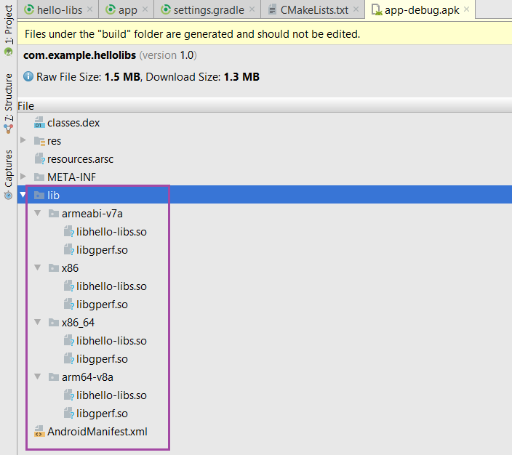

What fat APK use for?
Fat APK use to provide a single APK for multiple devices which has different ABI.

How fat APK support cross ABI?
When installing an application, the package manager sevice scans the APK, and look for any shared libaries of the form.
lib/<abi-name>/lib<name>.so

In this example, if you run apk on armebi-v7a devices, the package manager will copy libhello-libs.so and libgperf.so in armebi-v7a to the application data directory (data/data/<package_name>/lib/).

